Eder F. Torres Lopez

eder.fernando.torres3@gmail.com

Abstract

In embedded systems, sometimes it’s required to have an operating system to handle complex processes such as internet connection, advanced file handling, and use full speed USB peripherals such as webcams and Wi-Fi cards. These can’t be done by using microcontrollers, instead a microprocessor is needed. Due to the higher complexity of making a PCB for these advanced chips, a commercial single-board-computer is chosen to incorporate these advanced functions into a project. In this paper we go over on how to setup a BeagleBone Black to run Linux and how to set it up into a “headless” configuration, enable one of the UART ports and test it.

enable device tree overlays on headles beaglebone black

To enable UART ports and disable the HDMI and EMMC

Contents

Keywords and Glossary 2

Introduction and Prerequisites 3

1. Download the latest image for Debian 3

2. Image SD card with a Linux distribution for the BeagleBone 4

3. Connect to network and logging in into Debian 4

Optional: Disable EMMC (internal flash memory) and HDMI 7

4. Expand system on SD card 9

5. Remove Bonescript, Cloud9 and NodeRed 10

6. Install updates 10

7. Install minicom and use minicom 11

8. UART explanation and using minicom 12

9. Enable the Device tree overlay for UART communication port 15

10. Sending data with minicom through UART4 15

Conclusion 16

References and additional reading 17

# Keywords and Glossary

**Advanced IP Scanner:** Free Network Scanner to analyze local area network through the computer.

**Baudrate**: rate at which information is transferred in a communication channel.

**BalenaEtcher:** tool to flash OS images onto SD cards and USB drives.

**BeagleBone Black or (BBB):** low-power open-source single-board computer produced by Texas Instruments.

**Bonescript**: is a Node.js library specifically optimized for the Beagle family and featuring familiar Arduino function calls

**Cloud9**: is a cloud-based integrated development environment that lets you write, run, and debug your code with just a browser.

**Debian**: is one of the oldest operating systems based on the Linux kernel.

**Device Tree Overlay**: special device tree blob fragments that allow you to override specific parts of the device tree without having to re-compile the whole device tree. In other words, it’s a piece of code that changes the functionality of the pinouts of the BBB.

**EMMC**: embedded multi-Media card, in the BBB is the onboard flash memory, it can store the operating system.

**Headless**: headless configuration of the BBB is when you run the board without a screen attached to it.

**Image**: file with .img name extension and stores raw disk information, used to create backups.

**Logic Analyzer:** is an electronic instrument that captures and displays multiple signals from a digital system or digital circuit.

**Minicom**: is a text-based serial port communication program, it is used to talk to external serial devices.

**Nano**: small editor for the terminal of Linux.

**NodeRed**: allows to create functionality by wiring together flows of data between nodes using a browser. It is used by modeling bits of application functionality between devices like sensors, cameras, and wireless routers.

**Putty**: SSH client.

**SSH**: Secure Shell Protocol is a cryptographic network protocol for operating network services securely over an unsecured network.

**UART**: universal asynchronous receiver-transmitter is a serial communication protocol used to communicate two devices.

# Introduction and Prerequisites

This guide is meant to get started on a system that can be added to embedded system projects that are controlled with a microcontroller but have no access to advanced file system, internet controller, access to advanced USB peripherals such as webcams and other high-level functions and script languages. This method can be used to modularize embedded projects in such a way that a system can be upgraded by just swapping the daughter board that requires an upgrade and the rest of the system can remain untouched. It can be beneficial for mobile robotics, for example, that might need to do video processing and all the BBB processing power needs to be focused on that task and smaller boards can control other aspects of the robot such as drivetrain control and robotic arm movements, and all these boards can receive the needed commands from the UART ports from the BBB.

To follow this guide successfully it’s assumed that the following list have been gathered prior to starting:

* BeagleBone Black board (original)
* SD card (minimum 8GB, 32GB recommended)
* Ethernet Cable
* Network Router
* 5V power supply for BBB
* SD Card reader (if computer doesn’t have a built in one)
* It’s assumed that the user understands how to download and install programs in a responsible way to their personal computer and have administrator rights to do it

All the commands that will be run on the BBB terminal will be enclosed in double quotations and will be typed in Courier New font. A quick explanation of what the command does will be given before or after the command. For example: “sudo apt update” <- fetches the updated catalog for current installed programs.

Don’t expect to be commanded to “type” or “enter” before the command.

# Download the latest image for Debian

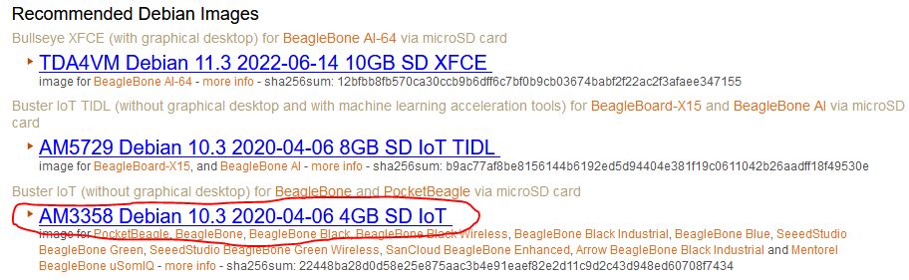Follow this link: <https://beagleboard.org/latest-images> and download “Buster IoT” for the AM3358 under the “Recommended Debian Images” Section. The link is usually blue, download the latest image available.

Figure : In this project the image used is the one circled with a red line.

# Image SD card with a Linux distribution for the BeagleBone

1. Download and install balenaEtcher from this link: <https://www.balena.io/etcher/> and install it on your computer.
2. Insert your microSD card to your computer.
3. On balenaEtcher click on: “Flash from file”, a window will open, look for the image you downloaded on Step 1.
   1. select your SD card. **MAKE SURE YOU SELECT THE CORRECT DRIVE BECAUSE ALL THE PARTITIONS AND DATA WILL BE ERASED!**
   2. Click on: “Flash!”, you will get a “Permission” dialog window. Click on “Accept” to start the flashing process. This step will take about 5 minutes depending on the speed of your computer, card reader, and card speed. It will take an additional 3 minutes to verify the image on the SD card. Once it finishes successfully eject the card safely.
4. With the power DISCONNECTED, insert the SD card into the BeagleBone SD slot.
5. 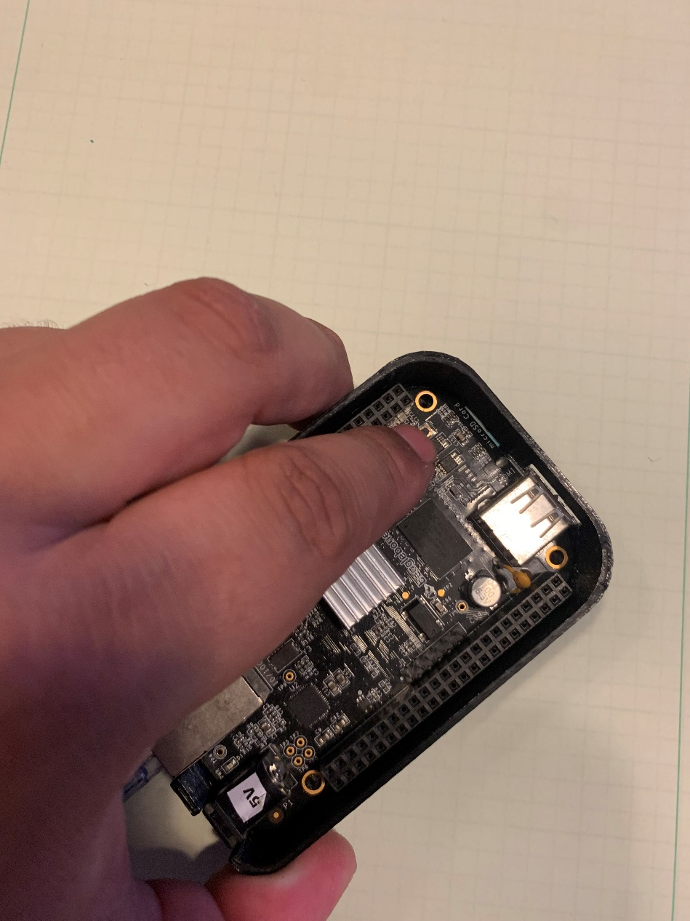To boot into Debian from the SD card and not it’s onboard flash memory, the USER/BOOT button must be pressed while the power is connected.

Figure :BBB has to buttons, USER/BOOT is boxed in a red rectangle

1. After all the lights turn blue and then off, you may stop pressing the button. After it has fully booted, the first LED will be blinking in a “heartbeat” fashion.

# Connect to network and logging in into Debian

Since we won’t be using a monitor for this setup, we will have to connect to the BeagleBone through SSH. Meaning that we will connect the board to the network through the ethernet port. After connecting to the ethernet port, and successfully booting into Linux, we need to figure the board’s private IP address. The easiest way for me to find the BeagleBone private address is by using “Advanced IP Scanner” on a computer that is on the same network as the BeagleBone, it can be downloaded from the following link: <https://www.advanced-ip-scanner.com/>

1. Once the BeagleBone is running, connect it to your network by using an ethernet cable (a Wi-Fi card can be added later). Having the green and orange light in the ethernet connector is a sign of communication. As seen in Figure 3, the BBB must be connected to the same router that your computer is connected to. The blue cable is the ethernet cable going from the router to the BBB. To communicate between your computer and the BBB internet is not required, but it is needed to download updates and other packages into the BBB. The computer that you are using to connect to the BBB doesn’t have to be connected to through ethernet cable to the router, it can be connected through Wi-Fi, if they are connected on the same network.

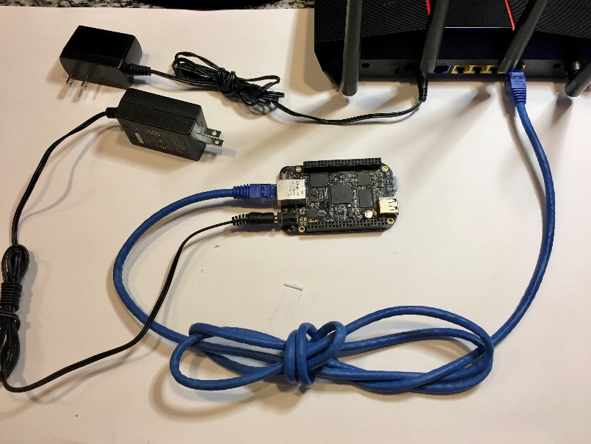

Figure : Basic BBB Connection (Ethernet cable demonstration)

1. 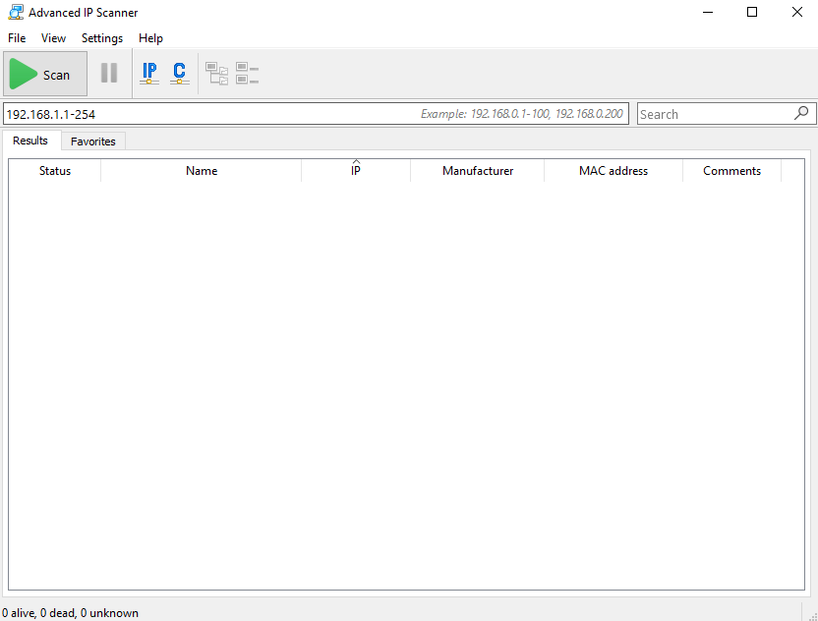Open “Advanced IP Scanner”, make sure that in the IP address bar you are in the correct range. I will have mine to scan from 192.168.1.1 – 192.168.1.254 as show in Figure 4. Depending on your router your IP address range might be different. You can try 192.168.2.1 – 192.168.2.254 if the first range didn’t work. The length of your listed devices after scan will depend on how many devices are connected to your network (you might even find devices that are getting “free” internet from you 😉).

Figure : The range in this case is: 192.168.1.1 - 102.168.1.254

1. 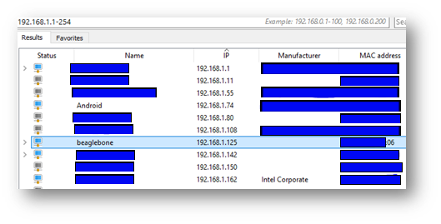The IP address that my BeagleBone was automatically assigned by the router is 192.168.1.125
2. To connect through SSH, PuTTy will be used. It can be downloaded from the following link: <https://www.putty.org/>

Figure : After scanning, these are some of the devices with the Private IP address given by the router. We are interested in the one with the name: BeagleBone. Its Private IP address is 192.168.1.125

1. In PuTTY, I’ll be connecting using the SSH protocol, port 22. And entering the IP address of the board. For quick connection, under “Saved Sessions”, a quick profile can be saved.
2. 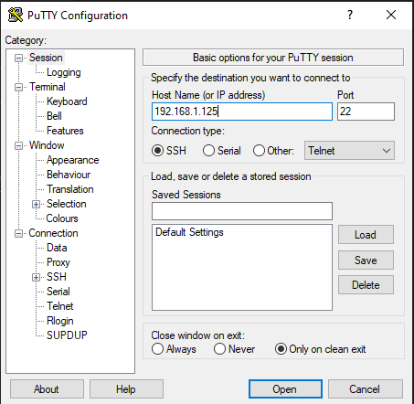You will be asked for the login username, the default username is “debian” and then you will be asked for the password, which the default is “temppwd”. It can be changed later, and it’s recommended. I will keep the default values for the rest of the document. Note: A warning message might pop up depending on whether this device has been previously connected to the same computer with a different IP address or not, since we know it’s our own BBB in our network, we can agree to connect to it if asked.

Figure : PuTTY window, the IP address gathered by the IP scanner has been put on the field "Host Name (or IP address)

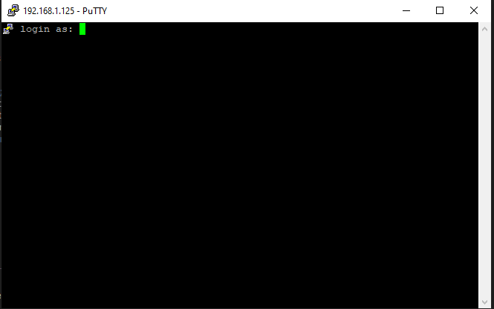

Figure : Terminal is asking to enter the name of username; in this case it will be "debian" (not including double quotes)

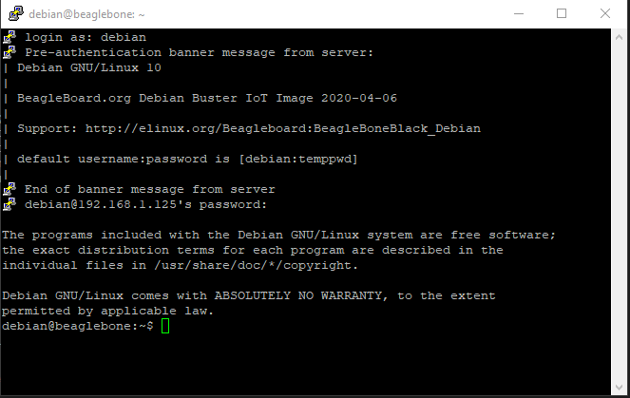

# Optional: Disable EMMC (internal flash memory) and HDMI

Figure : This is the message you get after successfully remoting in into the BBB

Since we’ll be running Debian from the SD card, we don’t need the internal memory to be enabled since they take up I/O pins that can be used for other purposes. Also, since we’ll be controlling the BBB through the network and won’t be connecting a screen to the HDMI port of the board, we can disable the HDMI port and have more I/O available for more devices. We need to modify the uEnv.txt file as a root. We use “nano” as the text editor to modify the file. Let’s do the following to disable these modules.

1. “sudo nano /boot/uEnv.txt” <- “sudo” is used to run “nano” as a super user or “root”. Otherwise, we won’t have permission to modify the file. Be careful when running commands using sudo. The text editor is included in most distributions of Linux.
2. 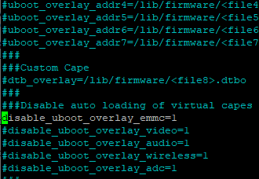Remove the “#” symbol on the line “#disable_uboot_overlay_emmc=1”

Figure : Inside the uEnv.txt file, we remove the "#" symbol in order to "uncomment" or tell Linux to NOT ignore this line and actually run it.

1. To save the modification done to the file and close the text editor, press “Ctrl” + “x” on your keyboard. You will be prompted if you want to save the changes. Press “y” and then “enter” to confirm.
2. 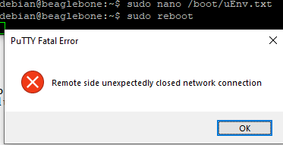Type “sudo reboot”, then enter the password if asked for it. <- “sudo reboot” will restart the BeagleBone

Figure : When the BBB reboots, it will disconnect from the network and PuTTY will let you know that it's no longer communicating with the board. A new session will have to be started.

1. 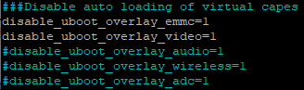After the system reboots, you will get an error that the connection is lost. This is normal, open another session as done before using PuTTY. Once back in the board, repeat the steps above, but this time remove the “#” symbol on the line “#disable_uboot_overlay_video=1” to disable the HDMI port and free up additional I/O in the header.

Figure : At the end we'll end up with EMMC and video disabled

1. Again, save the changes. Enter the password when prompted and reboot the BeagleBone again.
2. At this point both the EMMC and the HDMI port will be disabled.

# Expand system on SD card

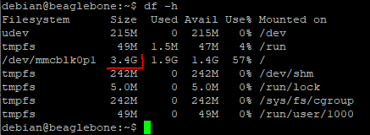The SD card that I’m using is 32GB of storage, but when I run the command: “df -h” I can see that I can only use 3.4GB. In the latest image of Debian, there is a script that will expand the partition to use the whole SD card, storage space might be needed to install applications, updates, and other user files.

Figure : /dev/mmcblk0p1 is the uSD card. It shows as it has only 3.4GB of storage when it should be close to 32GB

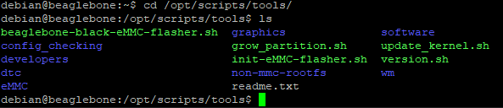In the folder “tools” of Debian, we can see the included scripts that can help us automate several things. We’ll be running “grow_partition.sh”. To go to this folder, we need to run the following command: “cd /opt/scripts/tools/” and then type the command “ls” to see all the files and folder on “tools” directory. “cd” is the command to “change directory” it is used when you want to go to a different folder. “ls” is the command used to list files or directories in Linux. All steps needed to expand the 3.4GB partition into using all the space available in the SD are shown below:

Figure : Running the "ls" command will list all files and directories in the current directory.

1. Enter the command: “cd /opt/scripts/tools/” <- it will change the current directory to the one specified
2. Then enter: “sudo ./grow_partition.sh” <- to run the file as an executable/script
3. Reboot by using: “sudo reboot” and log back again
4. Double check how much space is available for the mmcblk0p1 partition by using “df -h”.

Figure : We can see that the available space has increased from 3.5GB to 29GB

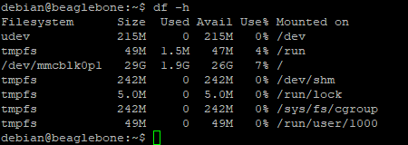

Now that we have all the space available, we can continue to download and install updates. But before that we should remove three systems that take up space and will slow down installing and downloading updates.

# Remove Bonescript, Cloud9 and NodeRed

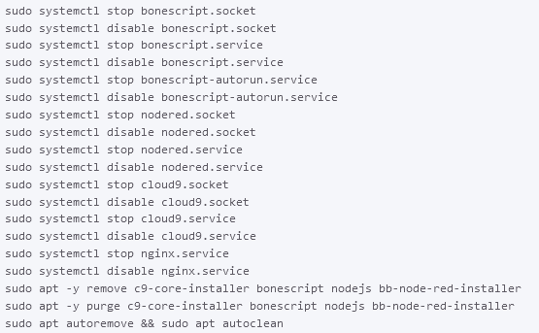I won’t be using Bonescript, Cloud9 and NodeRed to develop on the BeagleBone, I followed the steps on this page: <https://www.diozero.com/internals/bbbsetup.html> to remove them. This page has additional tips and steps that can help in the development and maintenance of the board. Type the command on the snipped bellow to free up space in the SD card and makes updating the board more efficient.

Figure : Commands listed in diozero.com to stop the bonescritpt and Cloud9 Services to remove them. Along with the command to remove NodeRed

for the commands: “sudo apt -y remove c9-core…” and “sudo apt -y purge c9-core…” I removed the “-y” for them to work. I typed the commands as follows:

* “sudo apt remove c9-core-installer bonescript nodejs bb-node-red installer”
* “sudo apt purge c9-core-installer bonescript nodejs bb-node-red installer”

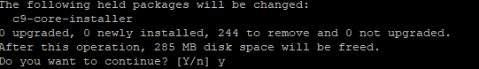 After each of these 2 commands were entered, you will be prompted if “you want to continue?”, press the letter “y” and then press the key “enter” on your keyboard

Figure : This is the message you will be to confirm the removal of the c9-core-installer package

After running all the commands, reboot the BeagleBone. Let’s get ready to install updates.

# Install updates

As in all OS, we should install the latest updates, updates can either add features, fix bugs and/or add security features. In Debian based OS (we installed Debian in this guide), we use two commands.

* “sudo apt update” downloads an updated list of the packages you currently have installed. You can think of it as updating a catalog magazine with its newest additions from the current applications you have installed.
* “sudo apt upgrade” downloads and installs all available packages that are on the list you just updated with the previous command. You can think of it as buying all the items in the catalog magazine.

Remember, “apt upgrade” will download and install whatever is in the saved catalog. If you want to install the newest packages and apps, you must “apt update” your catalog first.

1. Run the command: “sudo apt update”. Enter the password if requested. Depending on internet speed and what’s the current state of your OS, this might take a few minutes. Wait until it finishes.

Figure : After it finishes fetching the available packages, it will let you know how many can be updated.

1. 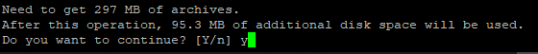Run the command: “sudo apt upgrade”. Enter the password if requested. Depending on internet speed and what’s the current state of your OS, this might take a few minutes. Eventually, you will get a message with a small report. At the end of the report, you are told how much of additional storage will be needed to complete the upgrade. Type “y” and then “enter”. Again, this might take a few minutes.

Figure : After running the "upgrade" argument, apt will let you know how much space it will be required.

1. For safe measure, run: “sudo reboot” to restart the board. Then, log back in.

# Install minicom and use minicom

To use the console to send commands, characters, strings, etc. through one of the UART ports, we need an application. The application I chose is called: minicom.

Minicom should not be able to be installed before the “apt update” command. But since we have done that step, we should be able to install minicom by running the command “sudo apt install minicom”. “apt install” will look for an application (in this case “minicom” and if it’s in the catalog, it will download it and install it.

1. Enter the command: “sudo apt install minicom”
2. 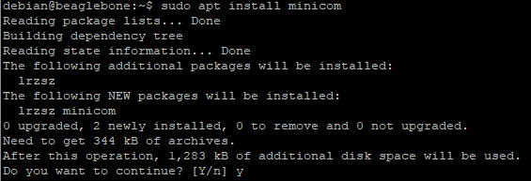You will get alerted on the space required, and what additional apps will be installed to install minicom. Press “y” and then “enter” to accept.

Figure : Message that should be sent by "apt". Press "y" and then "enter" to continue

# UART explanation and using minicom

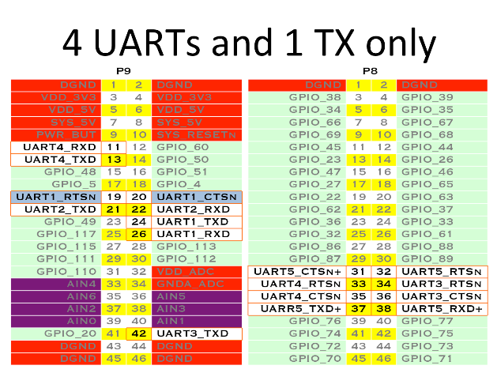To test minicom, we need to select a UART port to use on the BeagleBone. The board has 4 Full duplex UARTs plus one that only has the TX pin available. For this test I will be using UART4. The header pin order and location can be seen as follows:

Figure : Highlighted GPIO shows the available UART ports (credit: https://beagleboard.org/support/bone101)

UART4 pins are located on header P9 on pins 11 and 13. RXD (receiving channel) is on pin 11. And TXD (transmitting channel) is on pin 13. For the BBB to talk to other development boards or devices, both must have a common reference voltage, which we call “Ground”. Ground is labeled as “DGND” (digital ground) and can be found on several pins: 1, 2, 43, 44, 45, and 46 of header “P9”. And on pins: 1 and 2 of header “P8”. I will be testing the UART4 port and minicom by using a logic analyzer which can see the digital levels on the pins and record them in a wave form.

The logic analyzer’s software that I used has several functions, one is to just monitor a digital signal vs time, and the other is to try to interpret different common communication protocols, I will be using both. A UART-to-USB adapter may be used to test the system, but it won’t help to figure out if there are other issues such as timing issues, etc.

On UART communication, the TX pin of one of the devices must be connected to the RX pin of the other device and vice-versa. IMPORTANT!!! The BeagleBone logic level is from 0V to 3.3V, applying voltage higher than 3.3V on any pin (1.8V on analog pins) will damage the board. If the other device you are communicating with is higher than 3.3V, use shift level converter or use a voltage divider to convert the higher voltage to 3.3v.

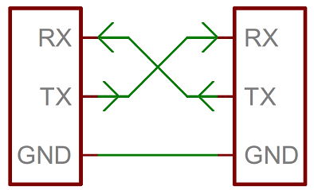Since the UART protocol is asynchronous, both devices communicating must agree on several specifications which are: Baud Rate (speed of transfer), number of bits to transfer per transaction, if there will be a parity bit, how many stop bits will be present (bit that tells the receiving device that the last bit has been sent and transaction is over), sometimes polarity can be chosen, meaning if the line will be logic “high” or logic “low” while idling.

Figure : Duplex connection of a UART connection

* 1. Connect ground signals together. Connect the BeagleBone’s UART4 TX line to the logic analyzer receiving pin. And connect UART4 RX to the sending pin of the logic analyzer.

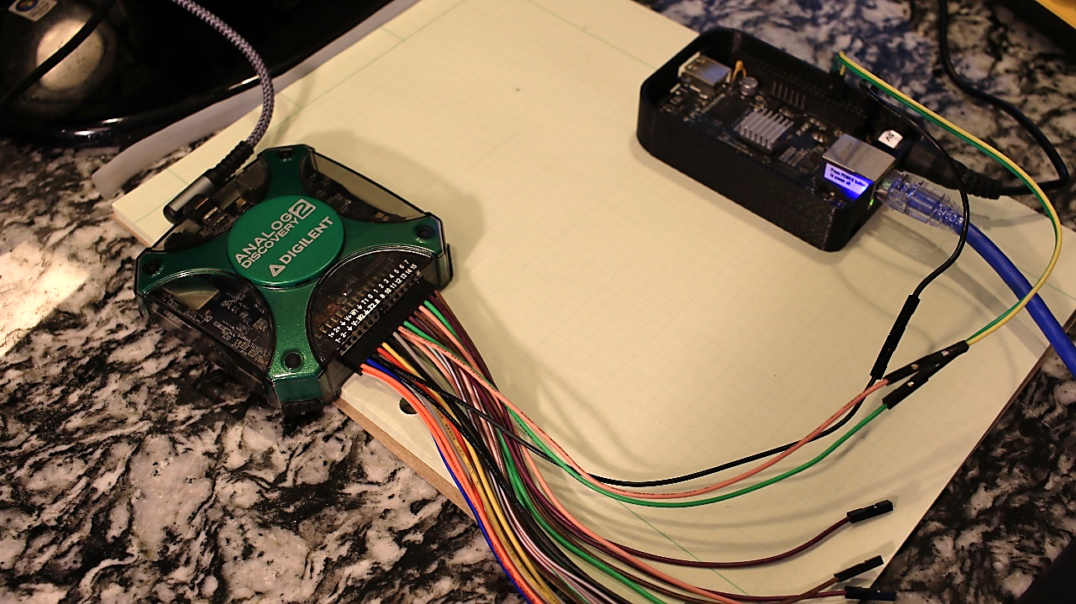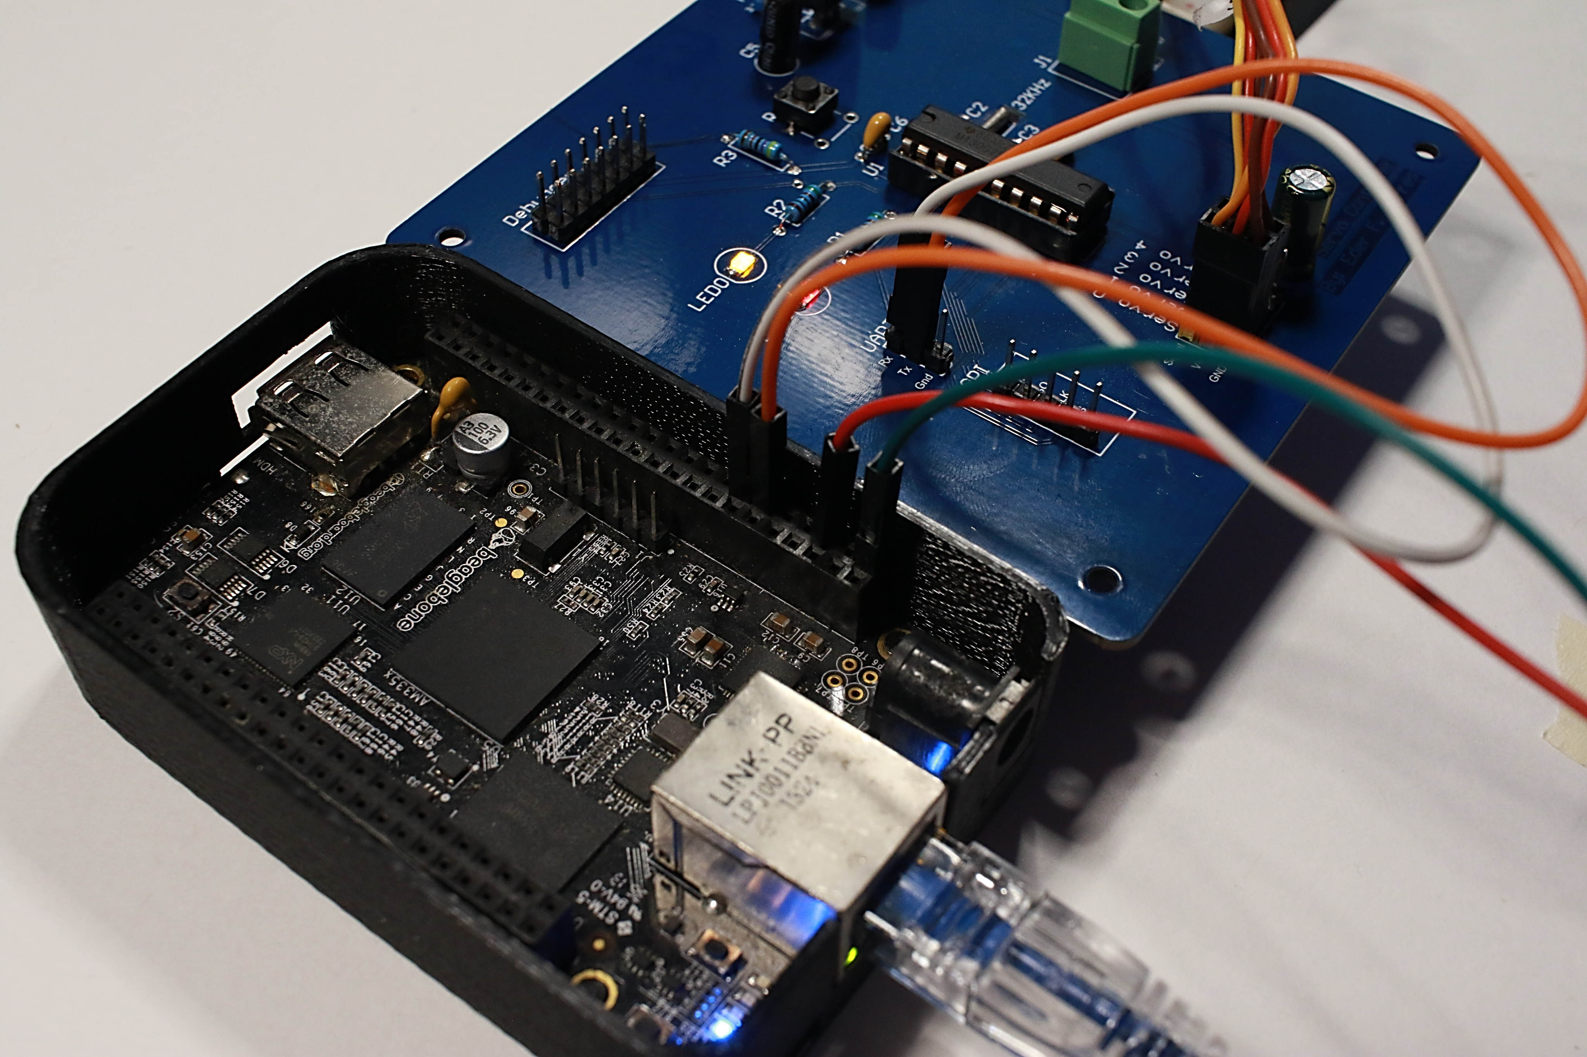

Figure : BBB connected to a Logic Analyzer, the green wire on BBB is the TX on UART4 and the yellow wire is the RX on UART4. The black wire is the common reference voltage (DGND).

Figure : As an example: The orange wire is connected to the RX pin of UART4 in the BBB and is connected to the TX pin of a daughter board. The white wire is connected to the TX of UART4 in the BBB and is connected to the RX pin of the Servo controller board

* 1. 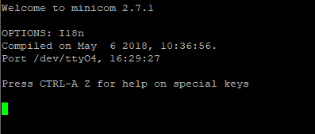Run the command: “minicom -b 9600 -D /dev/ttyO4” to open minicom and setup the communication settings. “minicom” is the application we are running for UART communication. “-b 9600” sets the baudrate to 9600. And “-D /dev/ttyO4” chooses UART4 to be opened on the BeagleBone as the communication port.

Figure : This is how the minicom interface looks like

* 1. Once minicom is running try typing letter or number, we won’t be able to see anything we type unless we enable the “echo” function.
  2. 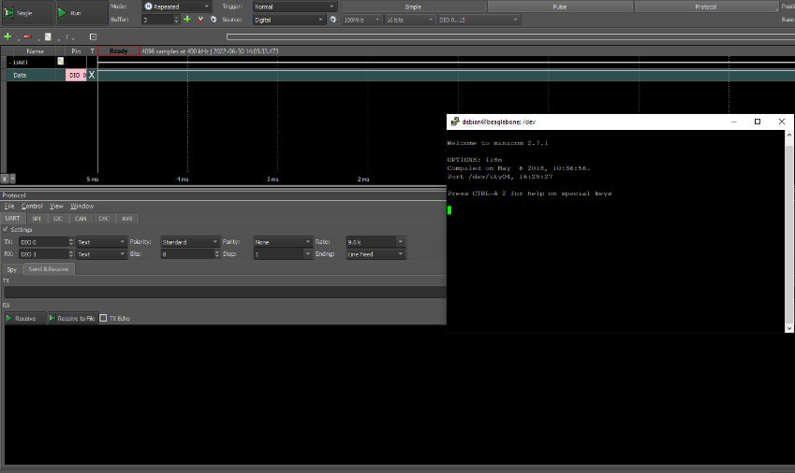NOTHING HAPPENED! Let’s fix it. Exit minicom by pressing “Ctrl” + “a” on your keyboard and then “z”. This will open a menu, we need to select “exit and reset”, let’s press “x” on the keyboard. Then press “y” to confirm the exit. In the next section, it will be explained how to fix this.

Figure : This shows both the logic analyzer window and the minicom window, none of them show activity after typing anything on the minicom terminal

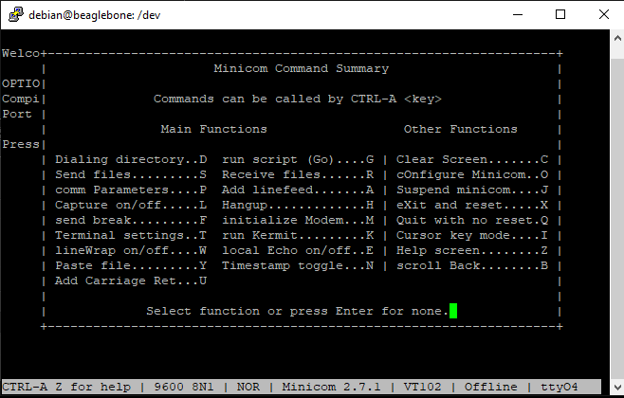

Figure : Press CTRL+a and then 'z' on the keyboard to show the command list for minicom.

# Enable the Device tree overlay for UART communication port

To use the UART4 communication, we need to enable it by editing the uEnv.txt. Just like we disabled the HDMI and the EMMC uboot overlay. We need to enable UART4 device tree overlay. Device Tree is a binary file that is read at boot time and sets the functions of each pin. This must be done since each pin can have more than one function. To change the functionality of each pin without recompiling the whole Device Tree, Device Tree Overlays have been created. These overlays will modify the Device Tree at boot time and configure the pins appropriately and the driver gets loaded for such function if necessary. There are currently several overlays already compiled and available in the BeagleBone’s directory: /lib/firmware/.

* 1. Type the command: “sudo nano /boot/uEnv.txt” <- to edit the uEnv.txt file with “nano”.
  2. Modify the line that says “#uboot_overlay_addr4==lib/firmware/<file4>.dtbo” to “uboot_overlay_addr4=/lib/firmware/BB-UART4-00A0.dtbo”
  3. Press “Ctrl” + “x” on your keyboard. Then “y” and then “enter” to save the changes to the same file.
  4. 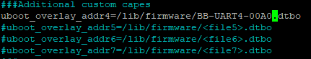Reboot the board.

Figure : the "#" has been removed and added the directory of the device tree overlay that we want to enable.

# Sending data with minicom through UART4

Now we are ready to use minicom to send data through UART. Let’s open minicom with the settings to use the serial communication at a baud of 9600 and use the UART4 which is the “TTYO4”.

1. Type: “minicom -b 9600 -D /dev/ttyO4”
2. As you type, the logic analyzer can see the pulses coming out of the TX pin of UART4 and display it in the window.
3. To exit minicom press “Ctrl” + “A”, then “z” to enter the menu. Then press “x” to exit. And then “enter” to confirm the exit.

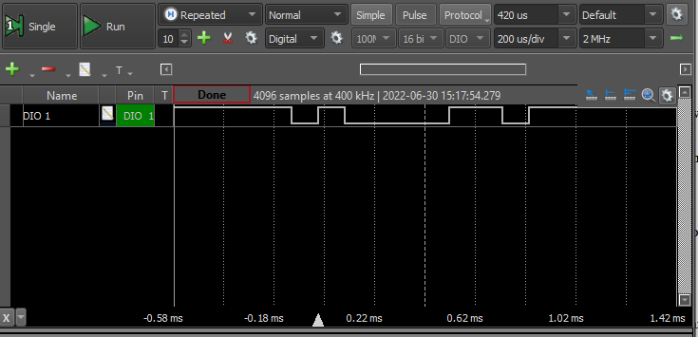When we pressed “a” while in minicom, the logic analyzer saw the following pulses on Figure 28.

Figure : Receiving pin on the logic analyzer show the voltage level vs time.

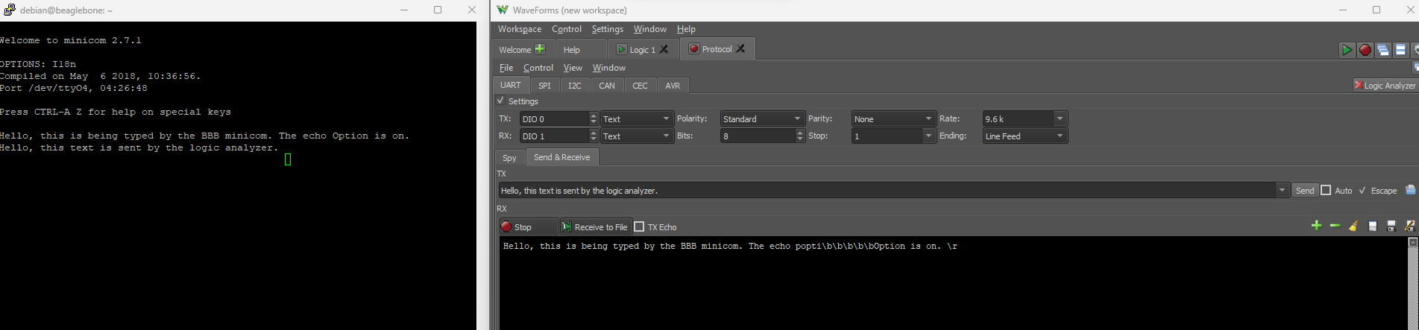When pressing keys using the protocol analyzer function of the logic analyzer and specifying UART. We can see all the data received from the TX pin as seen on Figure 29.

Figure : On the left we can see the minicom instance and on the right, we can see the logic analyzer window

On Figure 29, the minicom instance has the “local echo” function on so we can see what we typed. On the right, we can see the logic analyzer window with the received characters, noticed that the letters are not the same, that’s because on minicom, we typed the “backspace” key to correct typos, and the logic analyzer represents those keystrokes as “/b”. If we type something in the TX section of the protocol analyzer, then press “enter”. We can finally see something showing up the screen of minicom.

# Conclusion

This guide can be used to get started to interface a single board computer that runs Linux such as the BeagleBone Black to other embedded systems projects that required higher level functionality such as robust internet connection and use of advanced USB devices. It shows how to get started to connect the BBB without a screen and simple common commands that are used in Linux often. It also shows how to disable and enable device tree overlays to modify the default functionality of the general-purpose inputs and outputs on the BBB.

# References and Additional Reading

* <https://beagleboard.org/blog/2022-02-15-using-device-tree-overlays-example-on-beaglebone-cape-add-on-boards>
* <http://www.ofitselfso.com/BeagleNotes/Disabling_The_EMMC_Memory_On_The_Beaglebone_Black.php>
* <http://www.ofitselfso.com/BeagleNotes/Beaglebone_Black_And_Device_Tree_Overlays.php>
* <https://www.diozero.com/internals/bbbsetup.html>
* <https://beagleboard.org/support/bone101>